DIESEL GENERATOR SET

Model: DY-31YC. Rate Power: 31kVA/ 50Hz/ 3 phases
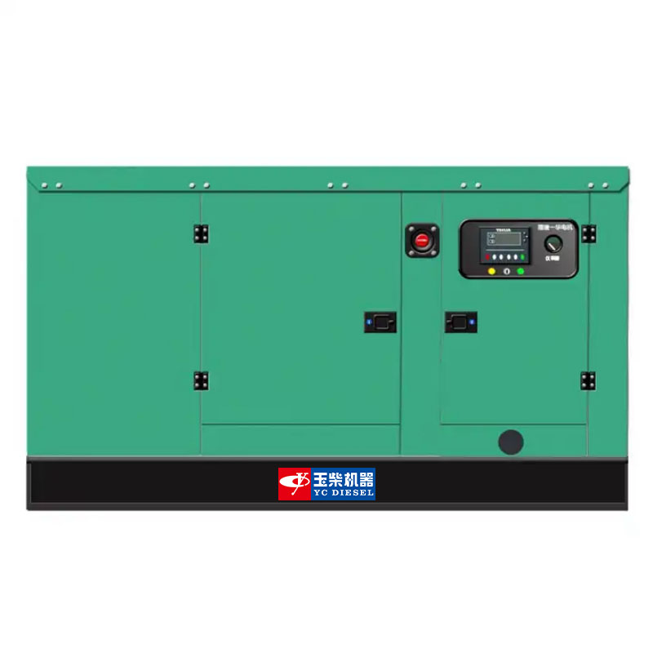
Applications:
Home, Buildings, Hospitals, Train station, Bank, Telecom, Mining, Military, Outdoor projects, etc.
• LCD display shows system status setup information

Generator Data

Prime Power (kVA) | 31
Standby Power (kVA) | 34
Rated Frequency (Hz) | 50
Running Noise db(A)/7m (Silent type) | 65±3
Voltage (V) | 230/380
Curent (A) | 45
No.Phase | 3
Silent Type-Dimension (LxWxH) (mm) | 1900x900x900
Silent Type-Weight (kg) | 700
Fuel Tank Capacity (L) | 120
Power factor | 0.8

Engine Model
Engine speed | Application | Generator set power |  | Engine power
Engine speed | Application |  |  | Gross power |  | Net power
r/min |  | kVA | kW | kVA | kW | kVA | kW
1500 | Prime | 30 | 24 | 38 | 30 | 35 | 28
1500 | Standby | 33 | 26 | 41 | 33 | 39 | 31

YCV2.5T45-G20 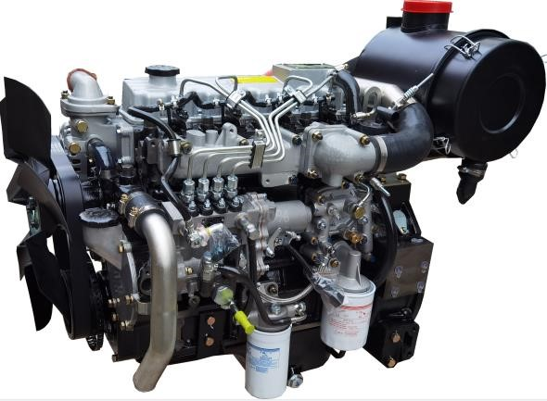

(
Image shown may not reflect actual engine
)

Prime Power
It corresponds to the prime rated power (PRP) of GB/T 2820 and ISO 8528, and refers to the maximum power accessible at the variable load for an unlimited running hours per year, with the maintenance intervals and procedures being carried out as prescribed by Yuchai, and the allowed average output power within 24 h shall not be higher than 70% of the prime power.

Standby Power
It corresponds to the emergency standby power (ESP) of GB/T 2820 and ISO 8528, and refers to the maximum power accessible at a certain variable load series in the event of a utility power outage or under test conditions for an limited running hours up to 200 h per year, with the maintenance intervals and procedures being carried out as prescribed by Yuchai. The allowed average output power within 24 h shall not be higher than 70% of the standby power.

Main technical parameters Centre of gravity (dry engine, with the center of the

rear end face of the flywheel shell as the origin)
Cylinder quantity ....................................................................... 4
From the rear end face of the flywheel………………............…../
Type .................................................................... Vertical, in-line
Height relative to the center of the crankshaft…………............./
Aspiration ............................................................. Turbocharged
Centerline deviation relative to the crankshaft center gravity
Combustion system ........................................... . Direct injection
……………………………………………………………….......…../
Valve quantity per cylinder ........................................................ 2

Moments of rotation inertia
Compression ratio ............................................................ 17.5:1
Engine ....................................................................................... /
Bore ............................................................................... . 89 mm
Flywheel ......................................................................0.31 kg·m²
Stroke .......................................................................... . 100 mm

Performance rating
Displacement .................................................................... . 2.5 L
Speed droop ....................................................................... ≤3 %
Rotation………Counterclockwise (viewed from the flywheel end)
Steady state speed band ................................................. ≤0.5 %
Firing order (viewed from front end)…..............................1-3-4-2

Test conditions
Minimum no-load speed ................................. . (700～750) r/min
Ambient temperature ......................................................... .25 ℃
Speed-regulation grade ........................................ . ISO 8528 G3
Atmospheric pressure .................................................... . 100 kPa
Dry weight (without radiator) .......................................... .220 kg
Relative humidity .................................................................. 30 %
Wet weight (without radiator) ........................................ . 250 kg

Max. operating intake resistance .................................... .≤5 kPa

Overall dimensions
Exhaust backpressure limit ............................................ ≤10 kPa
Length (from front end of radiator to rear end of air filter)
Fuel temperature (fuel inlet pump)…………………....…..38±2 ℃
…………………………………………………………….....1105 mm

Flywheel and flywheel housing size
Width . ……………………………………………………….634 mm
Flywheel………………………………………………………SAE 7.5
Height (with radiator and mounting support). .......... …....796 mm
Flywheel housing……………………………………………SAE 4#

Cooling system
Total coolant capacity………………………………………13.5 L
Engine coolant capacity………………………………….....2.5 L
Radiator coolant capacity…………………………………....10 L
Pipeline coolant capacity…………………………………….... 1L
Engine max. outlet coolant temperature…………………...98℃ Thermostat operation temperature:
Initial open………………………………………………...(70±2)℃ full open…………………………………………………......＜80℃
Max. coolant temperature rise:
-Standby power……………………………………………....8.5℃
-Prime power……………………………………………………8℃

Radiator
Cooling area……………………………………………..…13.1m²
Dry weight…………………………………………………....20 kg
Core material………………………………………….Aluminium
Width of core……………………………………………..508 mm
Height of core…………………………………………….480 mm
Min. pressure of pressure cap.................................(75±5)kPa
Coolant resistance limit………………………………..≤15 kPa Coolant pump
Rotation speed…………………………………………..4000 r/min
Drive mode.............................................................Pulley driven
Coolant flow………………………………………………..60 L/min Fan
Diameter…………………………………………………....430 mm
Drive ratio……………………………………………………1.37:1
Material………………………………………....................Plastics
Number of blades………………………………………………7
Type………………………………………………………....Blowing
Air flow…………………………………………………....60m³/min

Fuel system
Injection system...................Mechanical pump+electronic governor Injector
Type…………………………………......Mechanical+mulriple jets
Injector opening pressure ............... …………………….24 MPa Fuel pump
Drive mode ............................................................ Gear driven
Fuel delivery pump flow @1,500 rpm ........................... 1 L/min
Max. fuel inlet temperature limit ........................................ 70℃
Allowed fuel inlet pressure of front end of fuel delivery pump
(absolute pressure) ............................................ .(35~100) kPa
Maximum fuel return pressure of fuel pump .................. 20 kPa Fuel filter
Rated flow .................................................................. 1.2 L/min
Max. original resistance ................................................. . 7 kPa Filtering efficiency:
For particles of ≤4 μm.............................................. ≥98.5 %
For particles of （6~14） μm ...................................... ≥99 %
For particles of ≥14 μm ............................................ ≥99.9 %

Fuel consumption
Note: The density of diesel is 0.835 kg/L
Load condition | 1500 r/min
Load condition | g/(kW·h) | L/h
Standby | 230 | 9.1
Prime | 224 | 8.0
75% prime | 232 | 6.3
50% prime | 237 | 4.3

Lubricating system
Total oil capacity(dry engine) ............................................ 6.5 L
Total oil capacity(oil change) ................................................ 6 L
Oil sump capacity - low level/high level ........................... 3.5/6 L
Max. oil temperature (in oil sump) ………………………...125 ℃
Operating oil temperature(in oil sump)…………….. (90~110) ℃
Oil pressure(idle speed) ........................................... .≥100 kPa
Oil pressure(rated speed) ................................... (200~600) kPa
Oil-fuel consumption ratio ............................................. .＜0.2 % Oil filter
The filtering efficiency at the rated flow of 16 L/min and the assembly initial resistance ≤25 kPa:
For 15μm≤particles＜20μm................................................＞75%
For 20μm≤particles＜30μm................................................＞95%
For 30μm≤particles＜40μm................................................＞99%
For particles≥40μm...................................................＞99.9999%

Inclination
Transverse inclination(volume of engine oil sump:
6L).....................................................................................±10°
Longitudinal inclination (volume of engine oil sump:
6L) ……………………………………………………...........±10°
Intake system

Air filter
Max. intake resistance:
-Clean air filter ............................................................ . 2.5 kPa
-Dirty air filter ................................................................. . 5 kPa
-Air filter type........................Dry-type, filter cartridge of paper

Air intake flow
Prime power operation………………………………..2.04 m³/min
Standby power operation……………………………..2.11 m³/min Exhaust system
Max. exhaust backpressure ............................................. 10 kPa
Inner diameter of exhaust port pipe…………………....Φ48 mm
Exhaust temperature………………………………………＜600℃

Exhaust flow
Prime power operation………………………………....4.4 m³/min Standby power operation……………………………..4.56 m³/min

Electric system
Type………………………………………………..Negative ground
Charger
Voltage ......................................................................... 28V/14V
Output current ........................................................... 26.7A/65A
Starter
Type ....................................................................Electric start, 1
Voltage ......................................................................... 24V/12V
Power .................................................................... 4.5kW/3.7kW
Number of teeth of flywheel ................................................ .117
Number of teeth of starter ....................................................... 11

Cold start

24 V
Battery specification×quantity:12V/200Ah×2
Starting temperature | ℃ | -15 | -20 | -25 | -30
Starting speed | r/min | 215 | 185 | 153 | 138
Starting current | A | 246 | 305 | 342 | 372
Starting voltage | V | 20.16 | 18.96 | 18.48 | 17.9
Starting time | s | 2.6 | 2.9 | 4.8 | 5.6
Preheating time | s | 0 | 40 | 50 | 60
(test data, for reference)

Auxiliary intake heater (recommended)
Type .......................................................................................... /
Specification ............................................................................. ./

Water preheater (recommended)
Recommended specification. ............................... .1.5 kW/220 V
Engine preheater water outlet interface ...................... . NTP1/4
Engine preheater water inlet interface ...................... . M12×1.5

Oil heater (recommended)
Recommended specification. ................................ .150 W/220 V
Interface (oil sump, 1) ................................................ . M14×1.5

Noise

Noise data (30 kW @ 1500 r/min)

 |  | Engine  Flywheel end
  Position | Noise, dB(A)
  1 | 80.6
  2 | 86.6
  3 | 85.4
  4 | 90.3
  5 | 86.5
  6 | 87.5
  7 | 79.8
  8 | 80.9
  9 | 85.2

Noise spectrum (30 kW @ 1500 r/min)

 | 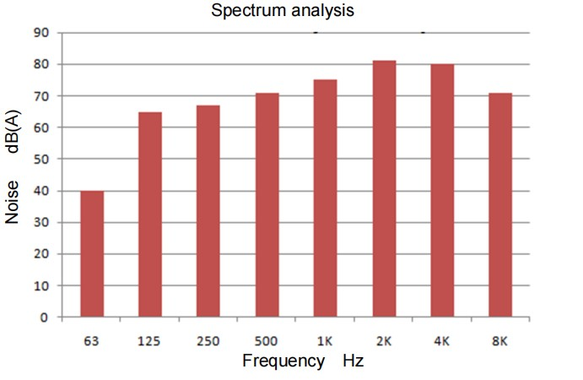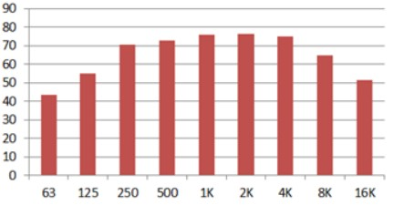
  Frequency, Hz | Noise, dB(A)
  63 | 43.2
  125 | 55
  250 | 70.5
  500 | 72.6
  1k | 75.7
  2k | 76.5
  4k | 75
  8k | 64.6
  16k | 52.9

Dimension
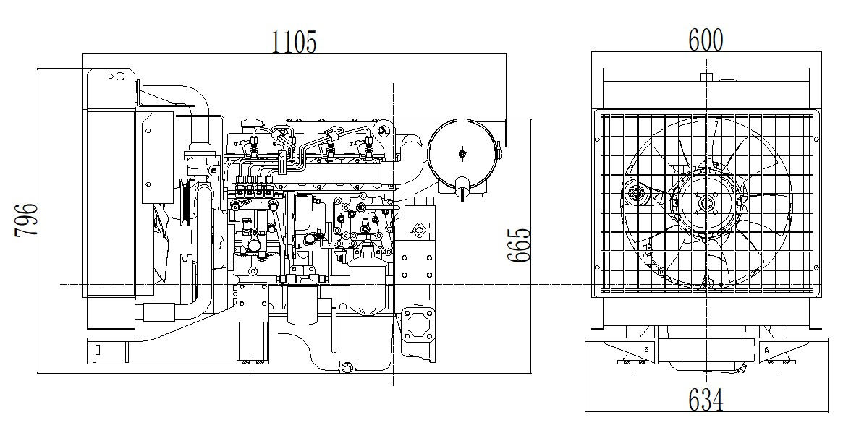

THREE – PHASE SYNCHRONOUS GENERATOR 三相同步发电机技术参数表

DY-31GB
Datasheet For 4 Poles - 50Hz @ 1500rpm / 60Hz @ 1800rpm
Ambient Temperature环境温度 | 40°C
Temperature Rise 温升 | 125°C
Insulation Class 绝缘等级 | Class H
Power Factor功率因数 | 0.8
Excitation 励磁方式 | Brushless无刷
Winding Pitch 绕组节距 | Two Thirds (2/3)
Pole极数 | 4
Voltage Regulation - in steady state condition 电压调节 | +/- 0.5%
Duty工作方式 | S1 - Continuous
AVR Model AVR型号 | ETC-A1

Short Circuit Current Capacity 短路电流容量 | >300%
Waveform : TIF | <50
Waveform : THF 波形畸变率 | <2%
Total Harmonic Content 总谐波含量 | < 2% - At no load
Method of Cooling 冷却方式 | IC01
Direction of Rotation 旋转方向 | Counter-clockwise顺时针
Maximum Over-speed 最高转速 | 2250 rpm
Degree of Protection / Enclosure 防护等级 | IP23
Altitude 海拔 | ≤1000 m.a.s.l
Radio interference 无线电干扰 | Class B Group 1

Electrical and Mechanical Characteristic 电气和机械特性

Frequency频率 | Hz | 50 | 60
Speed转速 | rpm | 1500 | 1800
Voltage ( series star ) 电压 | V | 400 | 480
Rated power at Class H (125º C) temperature rise额定功率在类  H(125ºC) 温升 | kVA | 31 | 34
 | kW | 25 | 27.5
Efficiency at Class H (P.F.=0.8) 绝缘等级H (P.F.=0.8) 效率 | 4/4% | 86 | 86.3
Efficiency at Class H (P.F.=0.8) 绝缘等级H (P.F.=0.8) 效率 | 3/4% | 87.3 | 87.7
Efficiency at Class H (P.F.=0.8) 绝缘等级H (P.F.=0.8) 效率 | 2/4% | 86.6 | 87
Efficiency at Class H (P.F.=1.0) 绝缘等级H (P.F.=1.0) 效率 | 4/4% | 89.2 | 89.7
Efficiency at Class H (P.F.=1.0) 绝缘等级H (P.F.=1.0) 效率 | 3/4% | 90.6 | 91.2
Efficiency at Class H (P.F.=1.0) 绝缘等级H (P.F.=1.0) 效率 | 2/4% | 89.9 | 90.5
H 绝缘等级 H
Short-circuit ratio 短路比 | Kcc | 0.3680 | 0.3680
Direct axis synchronous reactance unsaturated 直轴同步电抗 | Xd | 2.7170 | 2.7170
Quadrature axis synchronous reactance unsaturated 交轴同步电抗 | Xq | 1.3960 | 1.3960
Direct axis transient reactance saturated 直轴瞬态电抗 | X'd | 0.1880 | 0.1880
Direct axis subtransient reactance saturated 直轴瞬变电抗 | X"d | 0.1670 | 0.1670
Quadrature axis subtransient reactance saturated 交轴起始瞬态电抗 | X"q | 0.2040 | 0.2040
Zero sequence reactance unsaturated 零序电抗不饱和 | X0 | 0.0430 | 0.0430
Leakage reactance漏抗 | X1 | 0.1070 | 0.1070
Negative sequence reactance saturated 负序电抗饱和 | X2 | 0.1855 | 0.1855

Open circuit time constant (sec.) 开路时间常数 | T'do | 0.5140
Short-circuit transient time constant (sec.) 短路瞬变时间常数（秒） | T'd | 0.0310
Subtransient time constant (sec.) 超瞬变时间常数（秒。） | T"d | 0.0064
Armature time constant (sec.)电枢时间常数 | Tα | 0.0123
No load excitation current空载励磁电流 | io(A) | 0.5 | 0.5
Full load excitation current满载励磁电流 | ic(A) | 1.8 | 1.8
Full load excitation voltage 满载励磁电压 | uc(V) | 29 | 29
Stator Winding Resistance (20℃) 定子绕组电阻 (20℃) | ohm | 0.2137(Star Serie)星串联
Rotor Winding Resistance (20℃) 转子绕组电阻 (20℃) | ohm | 0.9082
Exciter Stator Resistance (20℃) 励磁机定子电阻 (20℃) | ohm | 17.22
Exciter Rotor Phase resistance 励磁机转子相电阻 | ohm | 0.04490Ω PER PHASE @20°C
Cooling air requirement 空气冷却要求 | m³/sec | 0.119 | 0.143

Configuration 结构 | Single Bearing单轴承 | Double Bearing双轴承
Type of Construction 结构形式 | B2 - SAE | IM B34
Inertia (J) [kgm2] 惯性（J）[ kgm2） | 0.29 | 0.284
Total Weight - kgs 总重量-公斤 | 178 | 175
Drive end bearing / Lubrication 驱动端轴承/润滑 | Not supply | 6306 C3-2Z / Prelubricated - sealed for life密封轴承
Non-drive end bearing / Lubrication非驱动端轴承/润滑 | 6306 C3-2Z / Prelubricated - sealed for life密封轴承
Recovery time - sec. 恢复时间 | 0.5
Stator winding 定子绕组 | DOUBLE LAYER CONCENTRIC同心式
Number of Terminal 终端数量 | 12
Rotor转子结构 | with damping cage带阻尼绕组
Overload超载 | 110% rated load for 1 hour 110%额定负载1小时

STANDARD COMPLIANCE - IEC 60034-1; CEI 2-3; BS 4999-5000; VDE 0530; NF 51-100,111; OVE M-10, NEMA MG 1.22.

Control Panel System

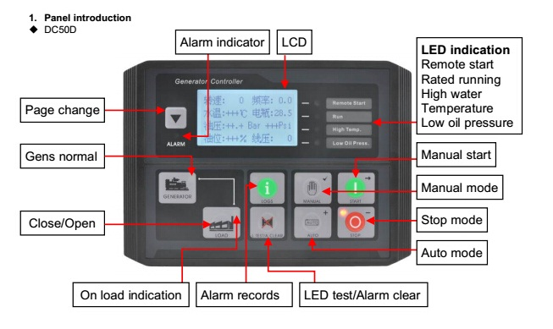

Main Features:
- Using microprocessor as a core, graphics LCD with big screen and backlight, key touch for operation  - All parameters use digital modulation, with higher reliability and stability  - Built-in speed/frequency detecting units can accurately judge the states such as crank success and over speed |  | - Security password-protected programming levels  - Power supply range is wide, accommodating to different starting battery voltage environment  - Built-in watch dog can never be dead halt, ensuring smooth program execution  - Modular configuration design, inserted type connection terminals, flush type installation, compact structure, easy installation
Precision measure and display of: |  | Protection:
 Generator voltage |  |  Emergency stop
 Generator current |  |  High water temperature
 Generator frequency |  |  Low oil pressure
 Generator active power (kW) |  |  Over speed
 Generator inactive power (kW) |  |  Under speed
 Generator apparent power (kVA) |  |  Loss of speed signal
 Generator power factor |  |  Generator over frequency
 Generator starts count |  |  Generator under frequency
 Generator hour count |  |  Generator over voltage

Data and Technical Specification are subject to change in order to update or improve the products, without prior notice

